Exercise 1: Setting Up Junit

JUnit
- JUnit is a Java testing framework used for unit testing.
- It helps developers test individual units of code automatically.
- JUnit improves code quality and simplifies debugging.

Dependency Used

<dependency>
<groupId>junit</groupId>
<artifactId>junit</artifactId>
<version>4.13.2</version>
<scope>test</scope>
</dependency>

OUTPUT
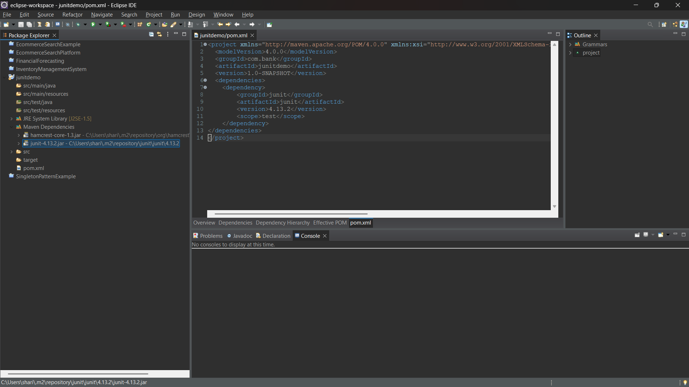

Exercise 3: Assertions in Junit

AssertionsTest.java

package junitdemo;
import static org.junit.Assert.*;
import org.junit.Test;
public class AssertionsTest {
@Test
public void testAssertions() {
assertEquals(5, 2 + 3);
assertTrue(5 > 3);
assertFalse(5 < 3);
assertNull(null);
assertNotNull(new Object());
}
}

OUTPUT

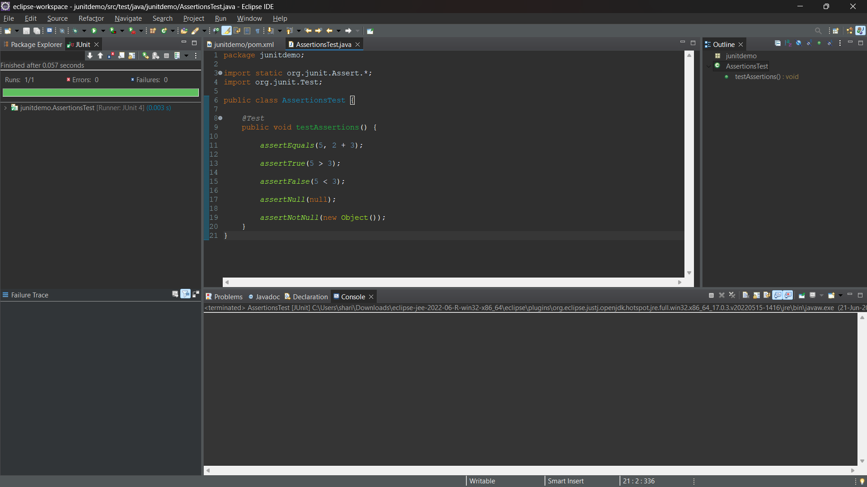

Exercise 4: (AAA) Pattern, Test Fixtures, Setup and Teardown Methods in Junit

Arrange: Prepare the test data and required objects before executing the test.
Act: Execute the method or operation that needs to be tested.
Assert: Verify that the actual result matches the expected result using JUnit assertions.
@Before (Setup Method): The @Before annotation is used to initialize test data and resources before each test case is executed.
@After (Teardown Method): The @After annotation is used to clean up resources and reset the test environment after each test case execution.
Result: The test case executed successfully using the AAA pattern, with setup and teardown methods running before and after the test, resulting in Runs: 1, Failures: 0, Errors: 0.

OUTPUT
